Role: Visitor Tea Room Volunteer Assistant

Dates Available: April 1st - September 30th 2019. Mon/Tue/Wed/Thu/Sun

Shift Times: 11 or 11.30 – 2 or 2.30 / 12.00 – 4.30 / 12.00 – 2.30 / 1.00 – 5.00

Commitment: Minimum of 6 hours per month

What the role involves: There are various roles available within the tea room and we will try to work around your preferences. You may be greeting customers, taking their orders, waiting tables, preparing drinks, serving cake and using the till. Also, within this team, you may be helping to prepare simple sandwiches, soups or jacket potatoes in our small kitchen, which will be fully stocked and prepped for the day by the staff team. As a volunteer here, you may be clearing tables and loading the dishwasher, and keeping the customer and kitchen area safe, clean and tidy. You may also be restocking the café tables both inside and those outside on the lawn. There may also be opportunities to help the staff prep for service for the day – this would be from 11 or 11.30 until 2 or 2.30.

Why it’s a great role to do: This is a sociable role working with a truly lovely team. The Catering Manager has created a really nice environment where visitors can enjoy refreshments and reflect on the garden. The small kitchen can get very busy at times, which suits the volunteers who don't like to be idle, but there could be some down time to get to know your co-volunteers too. The team here work closely together and warmly welcome new volunteers. It can be demanding work at times but there's also lots of chat and laughter. You are offered hot drinks and a home-made cake during a break in each shift and complimentary membership to the Friends of York Gate scheme.

Training Provided: You will have a formal but friendly induction, then you will learn the ropes through ‘on the job’ training by other volunteers and/or the catering manager.

Skills needed: You do not need any catering experience, we will show you the ropes. We ask that you have a friendly manner with the people around you.

Physical ability needed: This can be quite a physical role, it involves carrying trays, bending to load/unload the dishwasher, and being on your feet for most of your shift. That said, we currently have volunteers in their teens, right through to volunteers who have been retired for ten years or more.

Choose from:

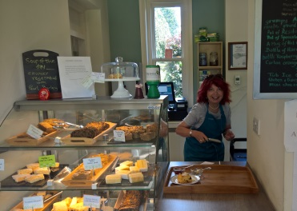
Washing Up

Waiting tables/hosting

Processing orders/till

Preparing lunches

Clearing tables

Preparing drinks

All areas

